



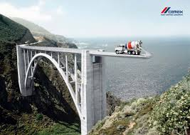



[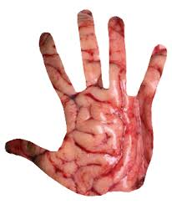](http://www.google.com.co/url?sa=i&rct=j&q=&esrc=s&source=images&cd=&cad=rja&uact=8&ved=0CAcQjRw&url=http%3A%2F%2Fwww.cosega.org%2F&ei=Qr4IVeqPKMG1sATtzoKYDQ&bvm=bv.88198703,d.cWc&psig=AFQjCNGV0cHmmjXNmqd-Fxu0iGW1EpgWag&ust=1426722736014000)

[](http://www.google.com.co/url?sa=i&rct=j&q=&esrc=s&source=images&cd=&ved=0CAcQjRw&url=http%3A%2F%2Fblog-comunicarte.blogspot.com%2F&ei=oL4IVc7pLeKxsAS5toLgAg&bvm=bv.88198703,d.cWc&psig=AFQjCNGV0cHmmjXNmqd-Fxu0iGW1EpgWag&ust=1426722736014000)

[](http://www.google.com.co/url?sa=i&rct=j&q=&esrc=s&source=images&cd=&cad=rja&uact=8&ved=0CAcQjRw&url=http%3A%2F%2Fes.slideshare.net%2FChrisZtar%2Fparadigmas-y-sintagmas-de-la-semitica&ei=gL4IVaKJIKPmsAS69YG4Dw&bvm=bv.88198703,d.cWc&psig=AFQjCNGV0cHmmjXNmqd-Fxu0iGW1EpgWag&ust=1426722736014000)

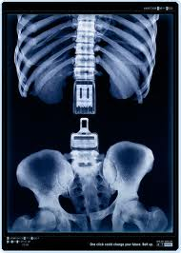

[](https://www.google.com.co/url?sa=i&rct=j&q=&esrc=s&source=images&cd=&cad=rja&uact=8&ved=0CAcQjRw&url=https%3A%2F%2Fsemioticapolacas.wordpress.com%2F2012%2F09%2F17%2Fejemplos-indice-icono-simbolo%2F&ei=2r8IVdapNtHjsATdiIKABg&bvm=bv.88198703,d.cWc&psig=AFQjCNGV0cHmmjXNmqd-Fxu0iGW1EpgWag&ust=1426722736014000)

1. [](http://www.google.com.co/url?sa=i&rct=j&q=&esrc=s&source=images&cd=&cad=rja&uact=8&ved=0CAcQjRw&url=http%3A%2F%2Flapacienciatodoloalcansa.blogspot.com%2F2010%2F02%2Fanalisis-semiotico-de-los-textos.html&ei=TsAIVajFOevdsATRv4GADA&bvm=bv.88198703,d.cWc&psig=AFQjCNGV0cHmmjXNmqd-Fxu0iGW1EpgWag&ust=1426722736014000)